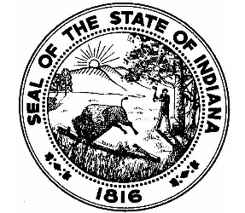

Office of the Lake County Assessor
LAKE COUNTY GOVERNMENT CENTER
2293 NORTH MAIN STREET

CROWN POINT, INDIANA 46307
February 13, 2026

RE: PTABOA Meeting Cancellation

Lake County Taxpayers:

Please be advised, the February 18, 2026 PTABOA Meeting has been cancelled due to the limited number of agenda items scheduled for this date. The next meeting will be held on March 4, 2026 at 9:30am.

If you have any questions or concerns, please do not hesitate to contact our office at 219-755-3100.

Sincerely,

LaTonya Spearman, Lake County Assessor
Level III Assessor-Appraiser
Lake County Assessor’s Office
2293 North Main Street
Crown Point, IN 46307
☎ (219)755-3105
✉ spearls@lakecountyin.org
🌐 https://assessor.lakecountyin.org


